University of Massachusetts Dartmouth

College of Engineering

Department of Electrical and Computer Engineering

CLASS SCHEDULE GENERATOR

A Honors

Project

by

Murilo S Silva Jr

# Abstract

How could the process of choosing classes be facilitated and improved in order to better fit ones schedule? CSG, for short, is a tool designed for students with its main purpose being to facilitate course selection during class registration. The goal of the class schedule generator is reached by matrix manipulation and analysis in MATLAB. Although the computations and schedule matrices are created in MATLAB, to facilitate user usability, the schedules generated will be exported to excel. This project was broken down in four major components: database read, course search, schedule generation, and schedule exportation.

Table of Contents

1 Abstract 2

2 Objective 4

2.1 Database Read 4

2.2 Course Search 4

2.3 Schedule Generator 4

2.4 Schedule Export 4

3 Procedure 5

3.1 Database Read 5

3.2 Course Search 5

3.3 Schedule Generator 5

3.4 Schedule Export 5

4 Results 6

4.1 Database Read 6

4.2 Course Search 6

4.3 Schedule Generation 6

4.4 Schedule Export 6

5 Conclusion 7

# List of figures

Figure 1: TBD 6

Figure 2: TBD 6

Figure 3: TBD 8

Figure 4: TBD 8

# Objective

This program will require the user to enter up to eight courses, and as an output it is going to display all the possible schedule combinations without time conflicts. Each component has its own objective.

## Database Read

For this application, the database consists of a static comma separated values file. The goals of this section are to read the file and parse to a MATLAB table with the appropriate data values and heading.

## Course Search

This section will be responsible for asking the user for the courses (up to eight) to be scheduled, and then find all their instances from the database and save them each on their individual matrices.

## Schedule Generator

Creating the schedule matrix will consist of: calculating the number of possible course combinations, create a matrix for each combination, eliminate matrices with time conflicts.

## Schedule Export

The remaining matrices from the previous component will be exported to excel, where they will be displayed in a weekly calendar view, thus helping the user define which schedule is better for him or her.

# Procedure

## Database Read

Reading the CSV file using MATLAB built-in function readtable. This will correctly load all the rows and columns from the CSV file to a MATLAB table. Optimize table by removing any unwanted spaces and columns containing unnecessary content.

## Course Search

Students are initially asked the number of courses they would like to search, and then the subject and catalog number of each class. Input is saved to a table.

Classes can have different components that must be taken simultaneously therefore the output from the search must reflect the different components as separate courses that the student must enroll in.

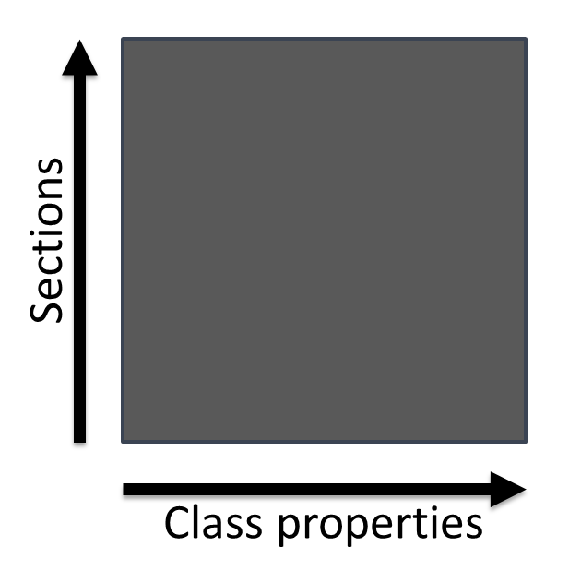

Figure 1: TBD

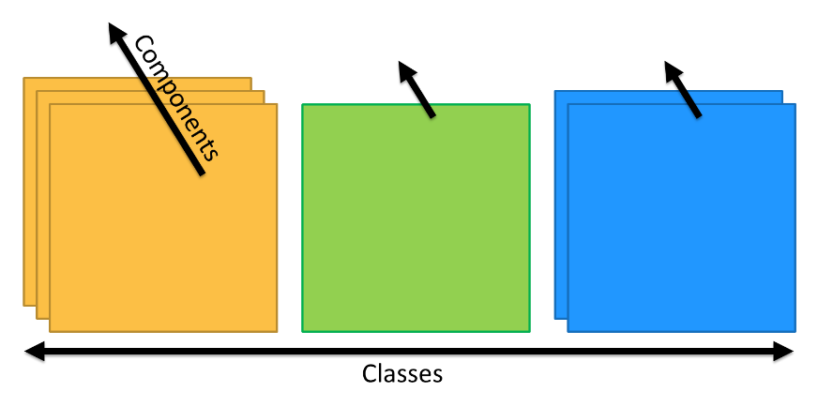

Figure 2: TBD

## Schedule Generator

The schedule generation starts by calculating the total number of combinations possible given the classes matrix, by multiplying the number of sections for each component and for each class.

After creating all the combination matrices then we must check for time conflicts, matrices with time conflicts will be discarded.

## Schedule Export

The outcome of the schedule generator will be exported to an excel file. The file will contain a separate sheet for each schedule possibility thus ensuring an easy visualization for the student.

# Results

## Database Read

After running DatabaseRead.m

Table T is created with the following elements:

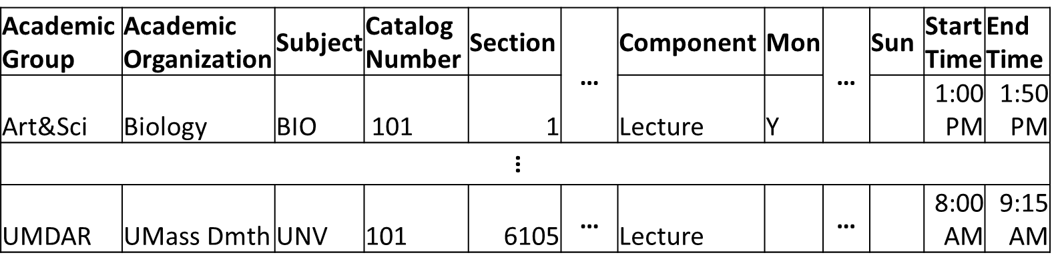

Figure 3: TBD

Where the first row is the header and columns are different properties of a class.

## Course Search

The user input is save to table C:

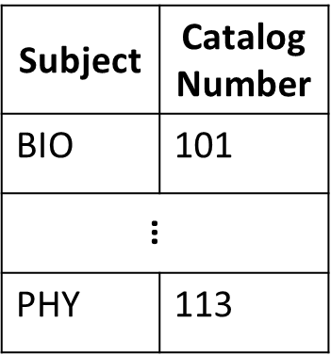

Figure 4: TBD

After comparing table T and C and only taking classes that contains the same Subject and Catalog Number cell P is created with the following:

## Schedule Generation

By calculating the number of possible schedules the possibility matrices are created:

Checking for time conflicts can significantly reduce the number of possible schedules but not always.

## Schedule Export

The generated schedule file has a schedule agenda such:

# Conclusion

Overall the Class Schedule Generator can be a great tool for students. The development was done through MATLAB because of its built-in libraries allowing for an easier interaction between the database (CSV) to the exported excel file. Moreover, the runtime of the program was slow (<9sec) because of the massive number of possible schedules when more than 3 classes were chosen. CSG still must go through many improvements to be a fully deployable tool, as a concept this render of CSG shows that it can be a possible and useful way for students to determine their class schedules in the future.